[](http://www.google.co.uk/url?sa=i&rct=j&q=&esrc=s&source=images&cd=&cad=rja&uact=8&ved=0ahUKEwiF4paNr-_JAhVM7RQKHQLsA3cQjRwIBw&url=http://www.bluebirdcare.co.uk/colchester/news/bluebird-care-colchester-at-williams-and-griffins&psig=AFQjCNE8hEgOh4aMlLW1DK_8J8hchsz2dg&ust=1450870263925087)

**Autumn Newsletter**

Bluebird Care Lancaster & South Lakeland

September 2024





We are well into our ***10 years celebrations*** and I am delighted to ***invite*** you and your family/friends to join us at our Willow Mill offices in Caton on **11th October (2-4pm)** for our next customer social:

***10 Years Special Afternoon Tea***

Many of our care staff will also be there looking forward to sharing a relaxing time. I’ve also invited a few extras, local people from the health and social care scene, who are keen to hear your perspectives on all things social care, what you like about receiving care, what you don’t and such like. No doubt David will produce a quiz – but I promise it will be super-short this time

Please can you RSVP to the office, so we can get the catering right. We can assist with accessible transport. Just let us know.

***NEWS***

There’s been plenty going on since by last newsletter in Spring.

**CATON GALA**

In May, we sponsored the ***Caton Gala*** for the first time. It was a great day, clear blue sunshine, loads of families and a fun time had by all. We had our own corporate hospitality tent. And our wonderful Beccy O had organised a pebble hunt for the children. A lady from the village had made us a special 10 year cake. This was my chance to thank the people who work and have worked here to help get us to where we are now.

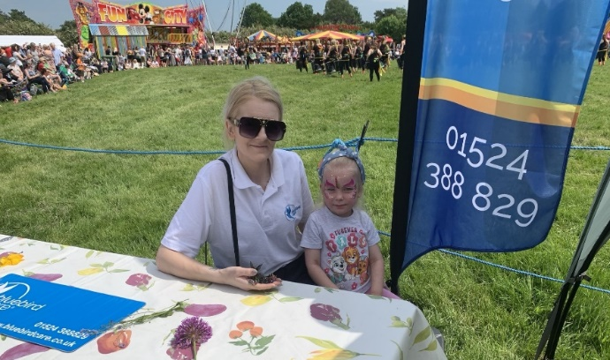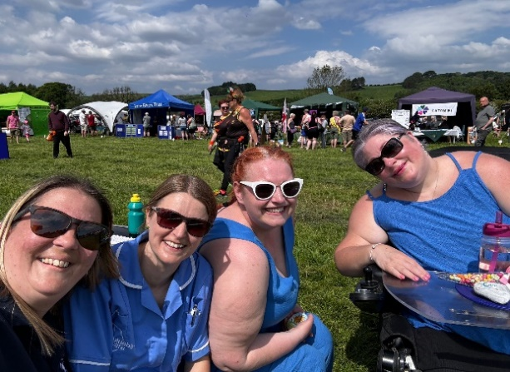

**CHARITY FUNDRAISER FOR ALZHEIMERS SOCIETY** 

In August we did the Cross Bay Walk on one the few sunny days of the year. Staff and their families braved the intense heat (and only young Jason Cayeux needed a lift from the tractor!) to make the 12km walk. It was a wonderful experience for everyone and we ***managed to raise a whopping* £2400 *for* Alzheimers Society a cause close to our hearts.** We were thrilled to bits that Neil, son of James F, took part and brought 3 friends with him. It felt like one big family crossing the sands of Morecambe Bay together

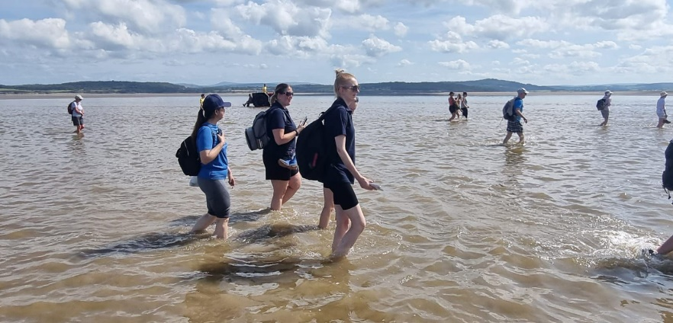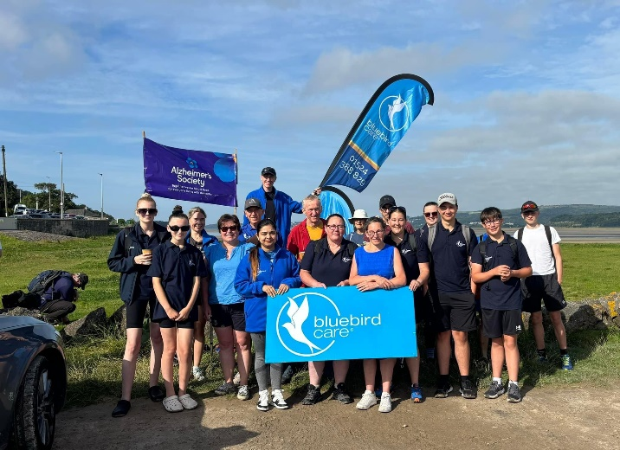

**MANAGEMENT NEWS**

We have a new Supervisors:

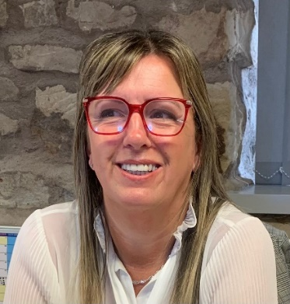***Toni Farrer*** Care Assessor. Toni is the main point of contact around your care service and any changing needs. Toni will also supervise staff performance in the field



***Ritika Tyagi,*** Supervisor. Ritika is office-based, regularly picking up telephone queries from customers and looking after our field staff

Everyone else remains in place:

Registered Manager – Alyson Hartlebury

Domiciliary Care Manager – Nicola Dryden

Coordinator – Nicola Dryden

Live-in Care Manager – Jana Cayeux

Rohit Kumar – Accounts (invoice queries)

**CUSTOMER SURVEY**



Thanks to everyone who took part in our survey this year Just over 40% of our customers or their families responded. Some highlights

* 95% felt comfortable and familiar with their care assistants
* 75% were fully satisfied with how tasks are completed
* 75% feel they are listened to and actions taken when their needs change.
* Only 55% felt they were informed is their care assistant is going to be late
* 30% felt that communication with the office team was sufficient

What people like about Bluebird Care:

* Professional, friendly, approachable, reliable
* Flexible, caring
* Service is of a high standard
* Carers are dedicated and committed
* Develop a genuine connection, contributing to a sense of safety and trust
* Responsive to changing needs and provide solutions
* Good timekeeping.

What customers feel needs improvement

* Communication from the office, especially around time changes and addressing customer feedback
* Carer consistency – fewer changes of personnel
* Consistency of task completion by carers

In Summary: There is much about our service that is strong so we will celebrate and sustain those standards. But in addition, we have developed an action plan to address those areas where improvement is needed. Key points:

* Comprehensive review of schedules and carer availability underway to identify scope for improving carer continuity for customers
* A new regime within the team for improving our responsiveness and ensuring effective communication across all aspects of the service
* Increase in regularity of oversight of staff performance

I hope that when we consult again in 6 months’ time, you will have noticed improvements. But in the meantime, please continue to let us know if you are not (or even when you are!) satisfied. We are a committed team and we love what we do: we want to do it better, so criticism is welcome.

**CELEBRATIONS!**

Congratulations to Lindsey B on the safe delivery of beautiful baby Lily

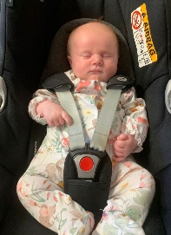

Our recent **Carers of the Month** have been:

Rebecca B – August

Fiona E – July

Tracey L - June

Prince M – May. Prince also won the quarterly Angela Award for exceptional performance in Care and Compassion; Team playing; attitude to learning and development.

WELL DONE EVERYONE!

We are holding our annual staff awards evening on 14th September, so I’ll report on that in the next newsletter. The ultimate award is for Carer of the Year. Who will it be…………?

And finally,

**A Day in The Life of a Registered Manager – Alyson Hartlebury**

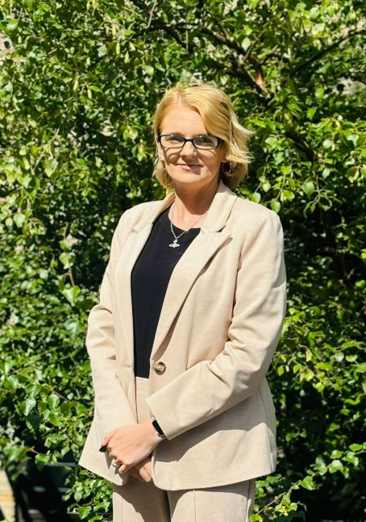

**Wake-up** I get woken up at around 5.30 – 6am by my partner and our 4 year old . Lucky me!

**Breakfast** is usually a very large cup of tea

**Get to the office** between 8.30-9am. Sometimes later if I have to cover an early morning care call. Unless there’s a crisis, I like to get myself prepared for the day by catching up on emails to find out how everyone is doing and prioritising what needs done.

**Tea or coffee?** Tea, preferably in one of my really huge cups (I mean *really* huge)

**Mornings** It can get pretty noisy in the main office, so if I need to get my head down, I retreat behind my office door. Sometimes, you have to separate from the day to day or you never get chance to stop and think strategically about the way forward.

I’m responsible for so many different things so no two days are even vaguely similar, let alone the same. For example, in one day I might: liaise with the district nurses about concerns we have regarding a customer’s skin; provide emotional and practical support to a carer who’s personal issues are impacting on their work; meet with the Directors to discuss the financial health of the business: and prepare a detailed written document for the CQC to evidence how we are compliant with health and social Care Laws. In and amongst all that, I am trying to study for my Level 5 qualification in Health and Social Care

**Lunch:** I spend far too much on takeaways, so we’ve clubbed together for a weekly shop and make home-made lunches. Much healthier. We have access to a slow cooker, a microwave and an air fryer in our kitchenette. Not bad and its nice to share**.**

**Afternoons**  We might have a meeting, whether a regular one or about something specific. Its so important to identify the issues and coordinate how best to tackle them. We work really well as a team, although I’d agree that our communication outside the office environment isn’t where it should be. I’m working on that.

Lately, I’ve been doing a lot of Annual Appraisals with our carers in the field. We have some amazing staff, talking to them is inspirational. Occasionally, someone isn’t up to the mark so I may need to address it quickly. That’s not quite so inspirational but it has to be done. We care for vulnerable people in the community so we need to employ carers we can fully trust

**Evenings –** I have three children so evenings are busy, although I’m also fortunate to have a hands-on partner. My youngest has just started school, I’m so proud of her. As the children settle down, I tend to do some extra work. This job is never done and there is so much to learn. I’m curious and I want to be the best I possibly can, so I love it! Some evenings, I have to cover care calls until 10pm. Its just the way this job is.

**My favourite thing about managing a premium care service** is getting to know the customers and their families. People have such interesting backgrounds and histories. And it feels great when we are able to help make things better.

**What do you like least about the role of Registered Manager?** I do miss doing hands-on care visits and spending time with our customers.

……………..

Best Wishes All

Claire